**EXPERIMENTAL**

**Preparation of Compounds**

5-benzylidenebarbituric acid and its substituted compounds were prepared by the modified procedure14.

To the calculated amount of the pure benzaldehyde (2 g, 0.015 mol) and barbituric acid (1.55g, 0.015 mol) in warm ethyl alcohol was added a 10% solution of sodium hydroxide (catalytic amount) and the reaction mixture stirred for 2 hours. After completion of the reaction as indicated by TLC, the reaction mixture was left overnight (scheme I). The solvent was removed in vacuum. The resulting crude product was purified by column chromatography.



(Scheme I)

**CHARACTERIZATION**

All the compounds were characterized as 5-benzylidenebarbituric acid and its derivatives (Fig.1) by 1H and 13C NMR spectral techniques. 1H and 13C spectra were obtained on a BRUKER AMX 400 MHz spectrometer. Chemical shift of 1H were measured with the peak of DMSO at δ 2.51 as the internal reference, while those of 13C were recorded with the central peak of DMSO at δ 39.90 as the internal reference.



Fig. (1)

**Assignment of 1H NMR Signals**

In 1H NMR spectrum of 5-benzylidenebarbituric acid whose, signals assignment was not difficult and all signals well separated from each other. The NH-proton of N8 and N10 atoms are expected to downfield than the -CH-proton of C5 carbon atom. The -CH-proton of C5 is well separated from all other protons signals, hence it’s assignment is not difficult. 1H NMR spectra of substituted 5-benzylidenebarbituric acids are given in Fig’s (2 - 8).

**1H NMR** Spectral data of substituted 5-benzylidenebarbituric acids are given below.

1. 5-(4’-Methoxybenzylidene)barbituric acid

δ 3.877 (s,3H), 7.065 (d,2H), 8.252(s,1H), 8.369 (d,2H), 11.175 (s,1H), 11.302 (s,1H).

2. 5-(4’-Hydroxybenzylidene)barbituric acid

δ 6.878 (d,2H), 8.213 (s,1H), 8.320 (d,2H), 10.851 (s,1H), 11.117(s,1H), 11.249 (s,1H).

3. 5-(4’-Methylbenzylidene)barbituric acid

δ 2.385 (s,3H), 7.304 (d,2H), 8.094 (d,2H), 8.255 (s,1H), 11.218 (s,1H), 11.365 (s,1H).

4. 5-Benzylidenebarbituric acid

δ 7.485 (m,3H), 8.073 (d,2H), 8.285 (s,1H), 11.238 (s,1H), 11.397 (s,1H).

5. 5-(4’-Chlorobenzylidene)barbituric acid

δ 7.518 (d,2H), 8.069 (d,2H), 8.243 (s,1H), 11.275 (s,1H), 11.425 (s,1H).

6. 5-(4’-Bromobenzylidene)barbituric acid

δ 7.670 (d,2H), 7.979 (d,2H), 8.223 (s,1H), 11.272 (s,1H), 11.421 (s,1H).

7. 5-(4’-Nitrobenzylidene)barbituric acid

δ 8.017 (d,2H), 8.245 (d,2H), 8.324 (s,1H), 11.329 (s,1H), 1.504 (s,1H).

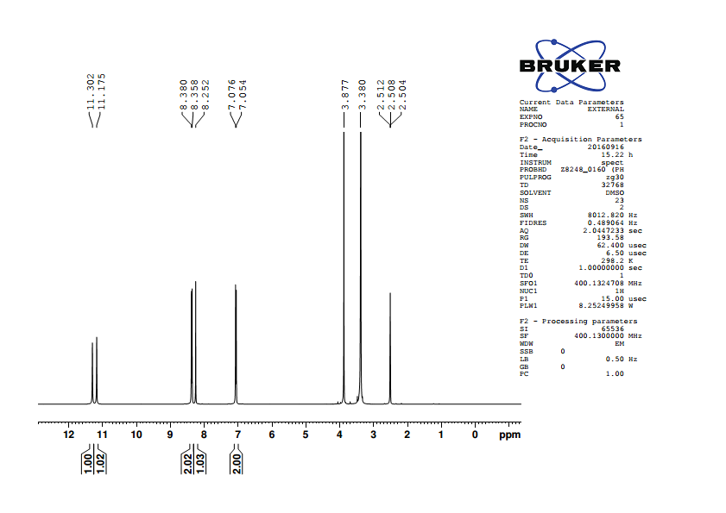

Fig.2. 1H NMR spectrum of 5-(4’-methoxybenzylidene)barbituric acid

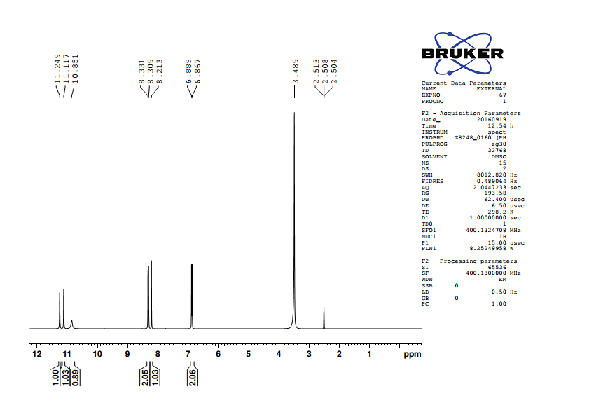

Fig.3. 1H NMR spectrum of 5-(4’-hydroxybenzylidene)barbituric acid

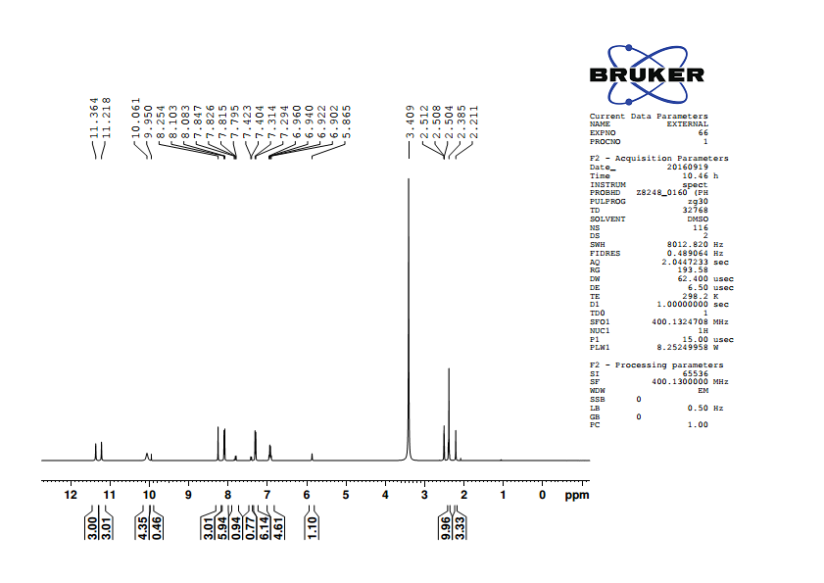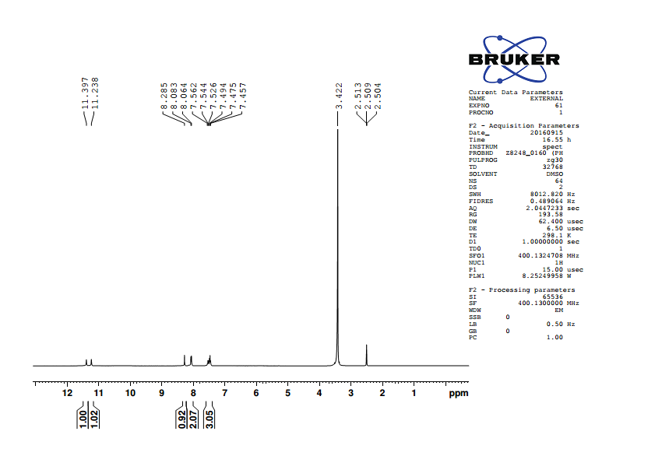

Fig.4. 1H NMR spectrum of 5-(4’-methylbenzylidene)barbituric acid

Fig.5. 1H NMR spectrum of 5-benzylidenebarbituric acid

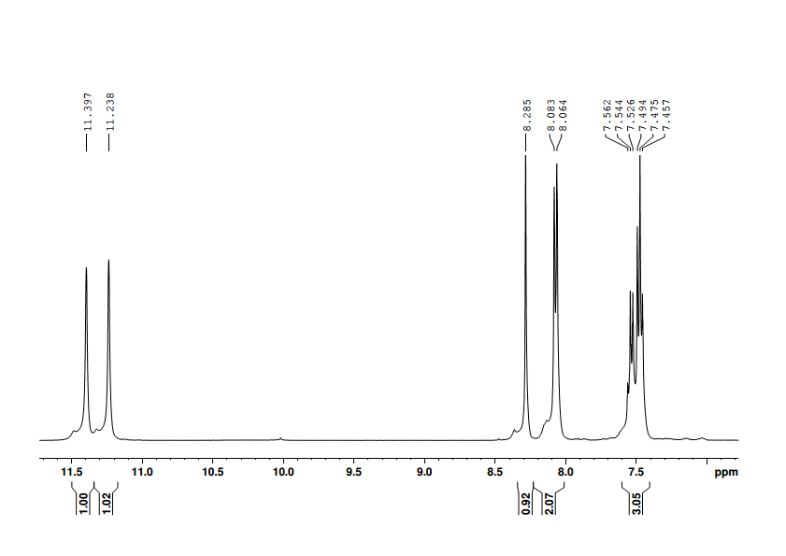

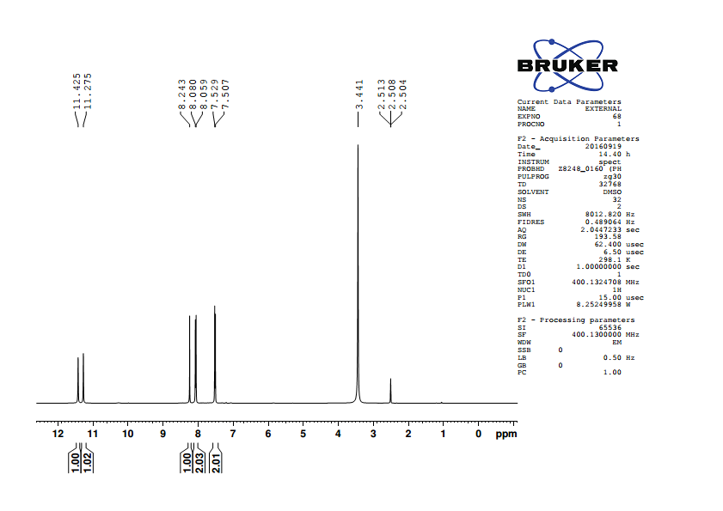

Fig.6. 1H NMR spectrum of 5-(4’-chlorobenzylidene)barbituric acid

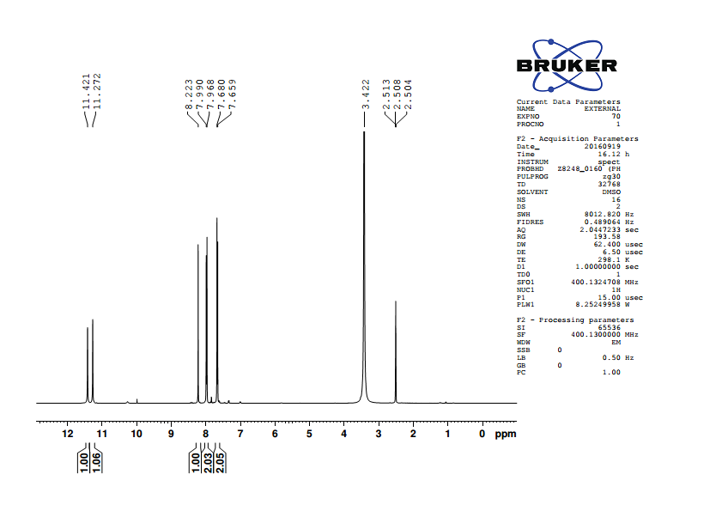

Fig.7. 1H NMR spectrum of 5-(4’-bromobenzylidene)barbituric acid

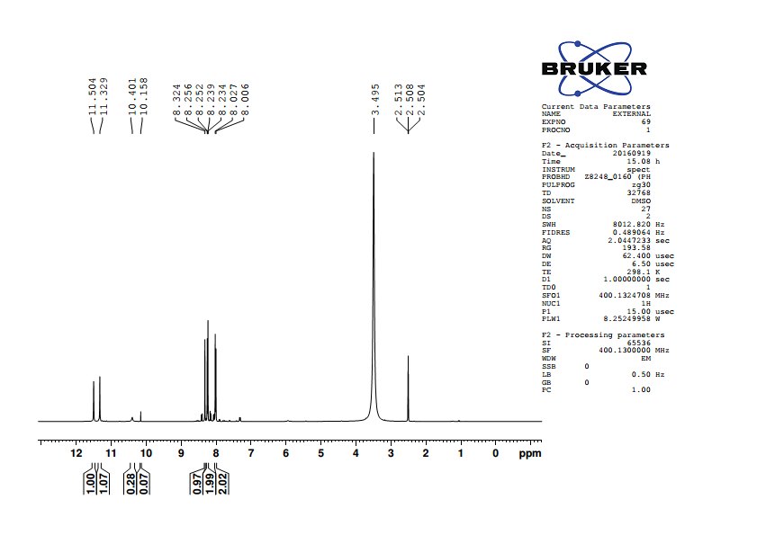

Fig.8. 1H NMR spectrum of 5-(4’-nitroobenzylidene)barbituric acid

**Table (1): 1H NMR chemical shifts of** **substituted 5-benzylidenebarbituric**

**acids**

|  |  |  |  |  |  |  |  |
| --- | --- | --- | --- | --- | --- | --- | --- |
|  |  |  |  |  |  |  |  |
| S.No. | Substituent, -X |  | H22’ | H33’ | H5 | H8 | H10 |
|  |  |  |  |  |  |  |  |
| 1. | -OCH3 |  | 7.065 | 8.369 | 8.252 | 11.175 | 11.302 |
|  |  |  |  |  |  |  |  |
| 2. | -OH |  | 6.878 | 8.32 | 8.213 | 11.117 | 11.249 |
|  |  |  |  |  |  |  |  |
| 3. | -CH3 |  | 7.304 | 8.094 | 8.255 | 11.218 | 11.365 |
|  |  |  |  |  |  |  |  |
| 4. | -H |  | 7.485 | 8.073 | 8.285 | 11.238 | 11.397 |
|  |  |  |  |  |  |  |  |
| 5. | -Cl |  | 7.518 | 8.069 | 8.243 | 11.275 | 11.425 |
|  |  |  |  |  |  |  |  |
| 6. | -Br |  | 7.670 | 7.979 | 8.223 | 11.272 | 11.421 |
|  |  |  |  |  |  |  |  |
| 7. | -NO2 |  | 8.245 | 8.017 | 8.324 | 11.329 | 11.504 |

**Assignment of 13C NMR signals**

13C NMR signals were assigned for various carbons were based on the

1. Chemical shift exhibited by the signals
2. Relative signal intensity
3. Empirical additivity rules

13C NMR spectrum of 5-benzylidenebarbituric acid contains 9 signal corresponding to 9 different carbon atoms. In all the spectra, carbonyl carbon signal was readily recognized and also well separated from other signals to downfield extreme, since its assignment was not difficult. 13C NMR spectra of substituted

5-benzylidenebarbituric acids are given in fig’s (11-17).

**13C NMR Spectra of 5-benzylidenebarbituric acids**

1*.* 5-(4’-Methoxybenzylidene)barbituric acid

δ 56.22, 114.41, 116.00, 125.62, 137.96, 150.67, 155.46, 162.64, 163.92, 164.39.

2. 5-(4’-Hydroxybenzylidene)barbituric acid

δ 114.61, 115.97, 124.24, 138.77, 150.70, 156.05, 162.75,163.48, 164.59.

3. 5-(4’-Methylbenzylidene)barbituric acid

δ 118.30, 129.33, 130.31, 134.43, 143.96, 150.68, 155.46, 162.26, 164.08.

4. 5-Benzylidenebarbituric acid

δ 119.55, 128.52, 132.69, 133.11, 133.54, 150.69, 155.20, 162.03, 163.87.

5. 5-(4’-Chlorobenzylidene)barbituric acid

δ 120.09, 128.55, 132.01, 135.15, 137.21, 150.65, 153.52, 162.04, 163.67.

6. 5-(4’-Bromobenzylidene)barbituric acid

δ 120.24, 126.29, 131.51, 132.40, 135.15, 150.65, 153.56, 162.04, 163.67.

7. 5-(4’-Nitrobenzylidene)barbituric acid

δ 123.15, 123.37, 132.69, 140.48, 148.49, 150.68, 151.63, 161.62, 163.13.

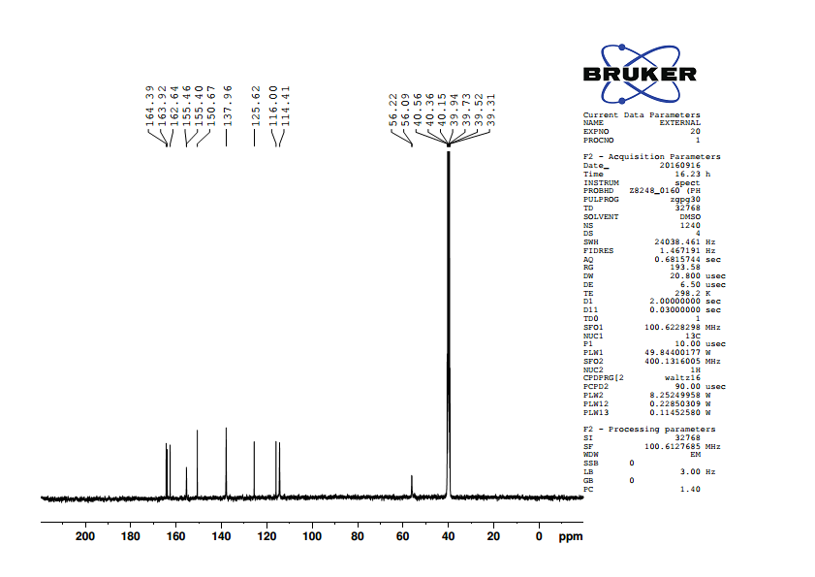

Fig.11. 13C NMR spectrum of 5-(4’-methoxybenzylidene)barbituric acid

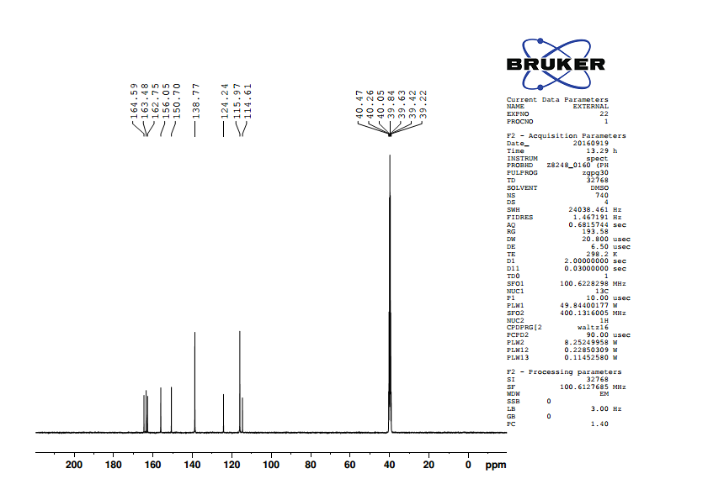

Fig.12. 13C NMR spectrum of 5-(4’-hydroxybenzylidene)barbituric acid

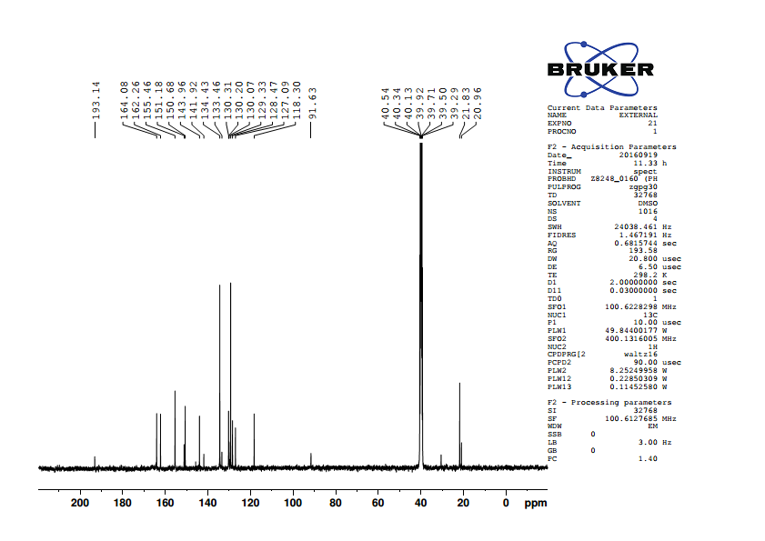

Fig. 13. 13C NMR spectrum of 5-(4’-methylbenzylidene)barbituric acid

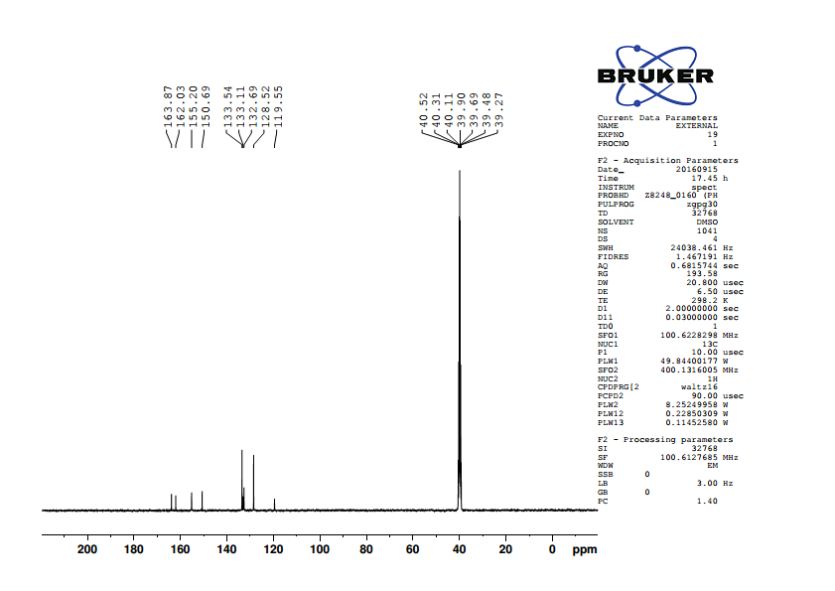

Fig.14. 13C NMR spectrum of 5-benzylidenebarbituric acid

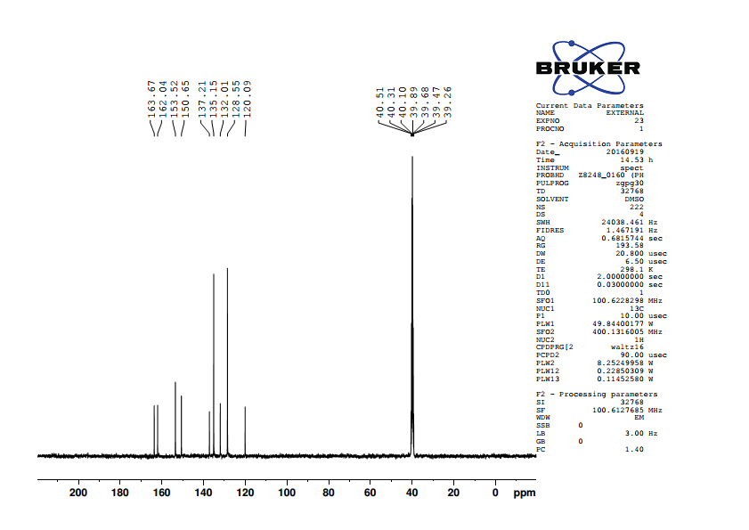

Fig. 15. 13C NMR spectrum of 5-(4’-chlorobenzylidene)barbituric acid

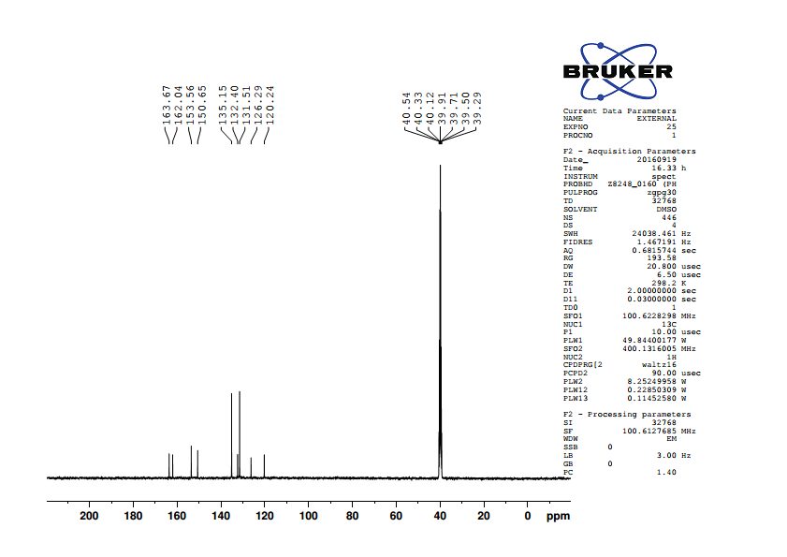

Fig. 16. 13C NMR spectrum of 5-(4’-bromobenzylidene)barbituric acid

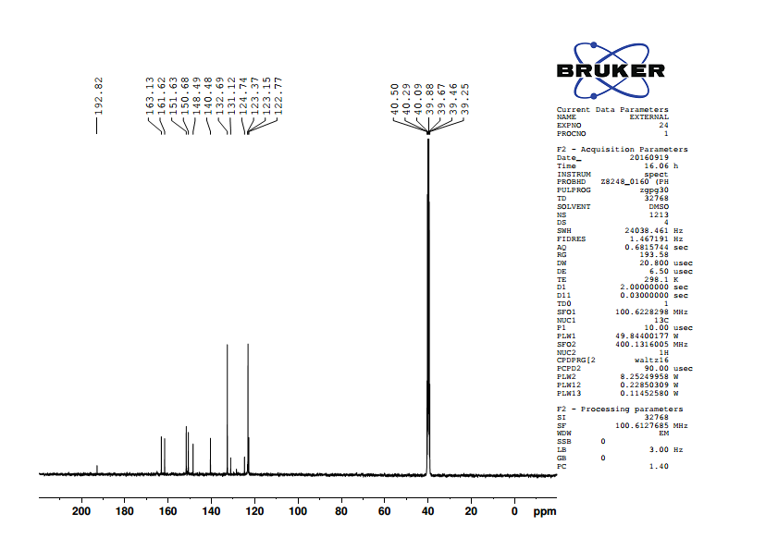

Fig.17. 13C NMR spectrum of 5-(4’-nitrobenzylidene)barbituric acid

**Table (5): 13C NMR chemical shifts of substituted 5-benzylidenebarbituric acids**

|  |  |  |  |  |  |  |  |  |  |  |
| --- | --- | --- | --- | --- | --- | --- | --- | --- | --- | --- |
| **S.No.** | *p*-X | **C1** | **C22’** | **C33’** | **C4** | **C5** | **C6** | **C7** | **C9** | **C11** |
|  |  |  |  |  |  |  |  |  |  |  |
| 1 | -OCH3 | 162.64 | 114.41 | 137.96 | 125.62 | 155.46 | 116 | 163.92 | 150.67 | 164.39 |
|  |  |  |  |  |  |  |  |  |  |  |
| 2 | -OH | 163.48 | 115.97 | 138.77 | 124.24 | 156.05 | 114.61 | 162.75 | 150.7 | 164.59 |
|  |  |  |  |  |  |  |  |  |  |  |
| 3 | -CH3 | 143.96 | 129.33 | 134.43 | 130.31 | 155.46 | 118.3 | 162.26 | 150.68 | 164.08 |
|  |  |  |  |  |  |  |  |  |  |  |
| 4 | -H | 133.11 | 128.52 | 133.54 | 132.69 | 155.2 | 119.55 | 162.03 | 150.69 | 163.87 |
|  |  |  |  |  |  |  |  |  |  |  |
| 5 | -Cl | 137.21 | 128.55 | 135.15 | 132.01 | 153.52 | 120.09 | 162.04 | 150.65 | 163.67 |
|  |  |  |  |  |  |  |  |  |  |  |
| 6 | -Br | 126.29 | 131.51 | 135.15 | 132.4 | 153.56 | 120.24 | 162.04 | 150.65 | 163.67 |
|  |  |  |  |  |  |  |  |  |  |  |
| 7 | -NO2 | 148.49 | 132.69 | 123.37 | 140.48 | 151.63 | 123.15 | 161.62 | 150.68 | 163.13 |